**Saint Brigid Saint John the Baptist**

4th Sunday of Easter

April 22, 2018

**Catholic Church Catholic Church**

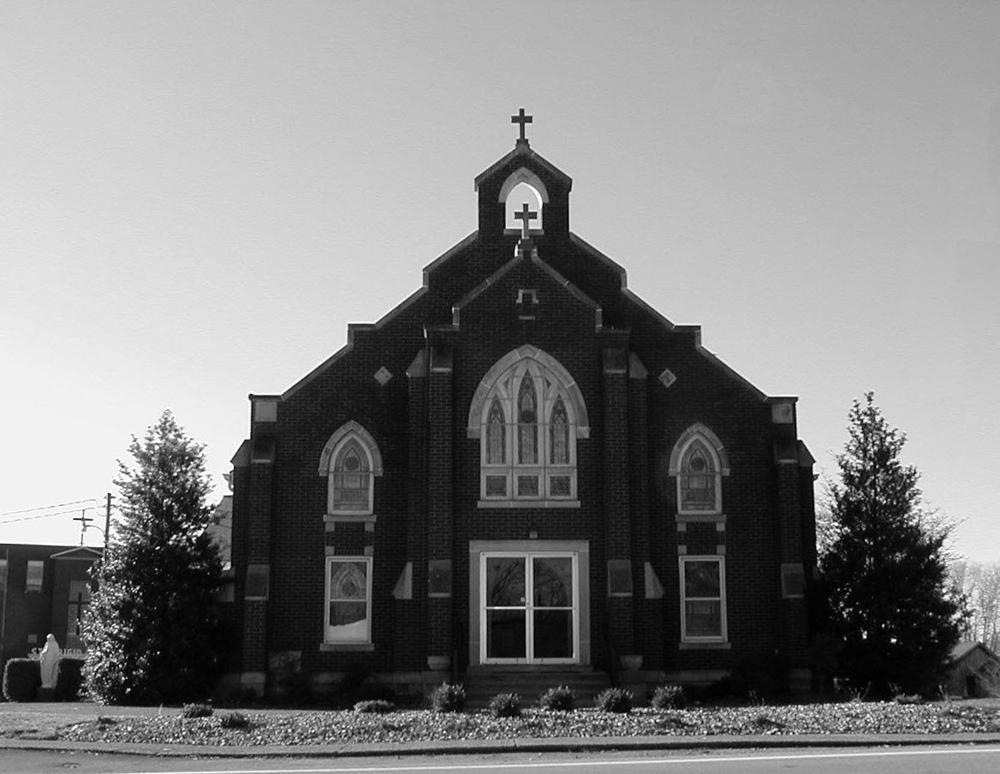

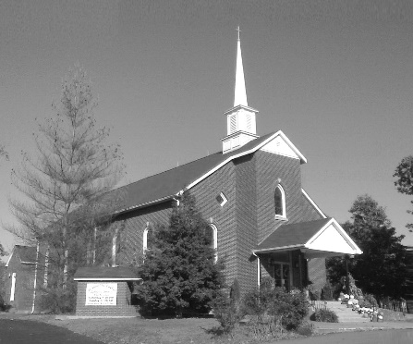

**Pastor:**

***Rev. Daniel L. Lincoln***

Rectory: (270) 877-2546

**Deacon:**

***Michael A. Ryan***

(270) 272-6789

314 E. Main St. 657 St. John Church Rd.

Vine Grove, KY 40175 Elizabethtown, KY 42701

Clustered Parish Office: Clustered Parish Office:

(270) 877-2461 (270) 877-2461

**ANNOINTING OF THE SICK:**

Notify the parish office when a family member is hospitalized.

**BAPTISM:**

Contact the parish office for information about the required preparation class.

**BULLETIN:**

Information must be submitted in writing by note or email to the parish office **no later than 12:00 noon on Wednesdays** for the following weekend. When sending an email, please put “BULLETIN,” and the name of the parish the announcement is for, in the subject line.

**MARRIAGE:**

Contact Father at least 6 months prior to the wedding date to complete required marriage preparations and to schedule the date.

**RCIA (Rite of Christian Initiation of Adults):**

Contact the Worship Chairperson for information.

**DEW MEMORIAL LIBRARY:**

(in St. Brigid Church basement):

Open: Sunday after 9:30 a.m. Mass& 45 minutes before all other Masses.

Email: [brigidvg@bbtel.com](mailto:brigidvg@bbtel.com)

Website:[www.stbrigidvg.org](http://www.stbrigidvg.org)

**Pastoral Associate & Dir. Dir. of Religious Education:**

**of Religious Education:** Lisa Thomas: (270) 735-6930

Deacon Mike Ryan: (270) 877-0546

**Youth Minister: Youth Ministers:**

Lori Law: (270) 723-0157 Angela Churchman:

(270) 268-9963

Ericka Finlay: (502) 612-2644

**MASS SCHEDULE:**

*Sunday:* 9:30 a.m. & 6:30 p.m.

*Monday:* 9:00 a.m.

*Thursday:* 9:00 a.m.

**RECONCILIATION:**

Sunday before Mass

5:30-6:00 p.m. or by appt.

**ROSARY:**

After weekday Masses

**PARISH COUNCIL MEMBERS:**

*President:* Sue Weisshaupt

*Vice-President:* Mike Bramlett

*Secretary:* Judy Cochran

*At-Large Members:* Blake Ryan

& Vincent Thompson

**CHAIRPERSONS:**

*Administration:* Dale Winchester

*Formation:* Tina Yates

*Parish Life:* Tom Billings

*Worship:* Keith Baughman

**MASS SCHEDULE:**

*Saturday (Vigil):*  6:30 p.m.

*Sunday:* 11:30 a.m.

*Wednesday:* 6:30 p.m.

*Friday:* 9:00 a.m.

**RECONCILIATION:**

Saturday before Mass

5:30-6:00p.m. or by appt.

**PARISH COUNCIL MEMBERS:**

*President:* Theresa Smith

*Secretary:* Karen Ray

**CHAIRPERSONS:**

*Administration:* Rick Newton

*Formation:* Ericka Newton

*Parish Life:* Bradley Wickersham

*Worship:* Nick Thomas



**Mass Schedule**

**Mass Schedule**

|  |  |  |  |  |  |
| --- | --- | --- | --- | --- | --- |
| **Saturday** | **April 21** | **6:30 p.m.** | **St. John** | **Bruce Sherrard** | **Vigil: 4th Sunday of Easter** |
| **Sunday** | **April 22** | **9:30 a.m.** | **St. Brigid** | **Our Parish Family**  **Mack, Leanna & Billy Cecil** | **4th Sunday of Easter** |
| **“** | **“** | **11:30 a.m.** | **St. John** | **For All Parishioners** | **“** |
| **“** | **“** | **6:30 p.m.** | **St. Brigid** | **Richard Hughes** | **“** |
| **Monday** | **April 23** | **9:00 a.m.** | **St. Brigid** | **Dickie Cecil** | **Easter Weekday** |
| **Wednesday** | **April 24** | **6:30 p.m.** | **St. John** | **For Special Intentions** | **St. Mark, Evangelist** |
| **Thursday** | **April 25** | **9:00 a.m.** | **St. Brigid** | **Carlos Robbins** | **Easter Weekday** |
| **Friday** | **April 26** | **9:00 a.m.** | **St. John** | **In Thanksgiving** | **Easter Weekday** |
| **Saturday** | **April 27** | **6:30 p.m.** | **St. John** | **Living & Deceased Emil & Anna Brangers Family Members** | **Vigil: 5th Sunday of Easter** |
| **Sunday** | **April 29** | **9:30 a.m.** | **St. Brigid** | **Clarence “Bud” Brangers** | **5th Sunday of Easter** |
| **“** | **“** | **11:30 a.m.** | **St. John** | **For All Parishioners** | **“** |
| **“** | **“** | **6:30 p.m.** | **St. Brigid** | **Sandi Crutcher** | **“** |

**INFORMATION FOR BOTH PARISHES**

**HAPPY EASTER!!** May the power of the Resurrection bring you joy, hope and peace throughout this Easter season! Fr. Dan and Deacon Mile.

**ABORTION AND ADOPTION –** The number of would-be adoptive parents (of newborn babies) far outstrips the supply in America. Each year in the United States, about 135,000 American children are placed for adoption. Experts estimate somewhere between one and two million couples seek to adopt yearly. Every year, there are about 1.3 million abortions. Sadly, only 4% of women with unwanted pregnancies give their children up for adoption. Every child is wanted and wanted desperately! By Pro-Life Articles Author [www.pro-lifearticles.org](http://www.pro-lifearticles.org)

**PROJECT RACHEL** **–** Healing…Forgiveness…Hope…After the experience of an abortion. If you or someone you know is struggling with the pain from an abortion, please consider Project Rachel – a post abortion ministry. To speak to someone confidentially, call (502) 471-2155 or email [ProjectRachel@archlou.org](mailto:ProjectRachel@archlou.org).

**CONFIDENTIAL PREGNANCY AND ADOPTION COUNSELING** – is available at Catholic Charities for women of all ages experiencing untimely pregnancies. A full range of services are provided, including adoptive placement, legal assistance and counseling for individuals, groups and families. Post-abortion counseling is also available. Services are provided regardless of income or marital status. For more information, call Catholic Charities at (502) 637-9786.

**SAVE THE DATE** – Fr. John Judie will have a celebration of his retirement, 70th birthday and 31 years of priestly ministry on **Saturday, August 11, 2018**. More details will follow later. He may be reached at (502) 774-5772.

. * * * * * * * * * * * * * * * * * * *

**St. John and St. Brigid Prayer List**

To add someone to the prayer list, please call the parish office at (270) 877-2461. **Remember to call to remove someone from the list if they are no longer sick, etc.** *Please note that the prayer list has been revised. It is primarily for parishioners and their immediate family members*.

Helen “Dinky” (Cowley) **Adams**, Sam **Adams**, April **Allen**, Dennis **Arnold**, Barbara **Ashley**, Donnie Alan **Atcher**, Sue **Banks**, Shannon **Barnes,** Denise **Barnett**, the **Bigler** family, Timothy **Birch**, Teresa **Laycock**, Charlie **Bowers**, Pauline **Brangers**, Wanda **Branson**, Ellen **Bryan**, Richard **Bryson**, Carol **Buchanan**, Jeremy & Margie **Buyer**, Ashley **Butler**, Deacon Bob **Caspar**, Sue **Caswell**, Ed **Cecil**, J. Mack **Cecil**, Harlan Ford **Clark**, John **Connor**, Betty Jo **Cooper**, Heidi **Correa**, Jeff **Craig**, Glynn **Clutches**, Roan **Dowell**, Karen **Dworshak**, Leroy **Embry**, Martha **Ford**, Dwayne **Garcia**, Carrie **Gribben**, Mary **Hager**, Mrs. Charles **Hair**, Stephanie **Hall**, Donnie **Hart**, Jimmy **Harper**, Bobby **Harris**, Debbie **Hodge**, Betty Lou **Jones**, Andrew **Kieta**, Jenny **Leonhardt**, Jackie **Long**, Louise **Lucous**, Alma **Mahanna**, Shelly **Martin**, Shirley **Martin**, Martina **Masoni**, Don **Mattingly**, Paul Michael **Mattingly**, Mary **Medley,** Cindy **Miller**, Starla **Miller**, Doug **Osborne**, Duane **Osborne**, Mickey **Padgett**, Frank **Inanely**, Polly **Prather**, Annie **Pierce**, Adrianna **Porter**, Jeremy **Porter**, Adrian **Ray**, Allie **Ray**, Mary Agnes **Ray**, Mary Ellen **Ray**, James S. **Reed**, Sharon **Reed**, Tonya **Reisinger**, Joel **Rivera**, Caroline **Seabee**, Darlene **Staples**, Ralph **Staples**, Joan **Stith**, Keith **Tassin**, Kenny **Thompson**, Charles **Tucker,** Raffaella **Tucker**, Debi **Turner**, Charlotte **Vowels**, Bill **Waldrop**, Lois **Weaver**, Paul A. **Whelan**, Jennifer **Williams**, Sandy **Wiseman**, Zach **Wiseman**, Gail **Wilson**, Don **Wooldridge**, Connor **Wright**, Rose Marie **Yates** and all the sick.

* * * * * * * * * * * * * * * * * * *

**Our Military List**

To add someone to the military list, please call the parish office at (270) 877-2461. **Remember to call to remove someone from the list if they are no longer in the service**.

Lt. Matt **Bednar**, PFC Richard H. **Chapman**, A1C Brandon **Davila**, SrA Felicia **Esquivel**, PFC Tyler **Hall**, A1C Ryan **Henley**, A1C Joseph **Manco**, SPC Jacob L. **Nall**, SFC Peter **Novak**, Tony **Rickerl**, Lt. Col. Paul **Rigby**, 0James **Rogers**, Tony **Rogers**, Jonathon **Sifford**, Jeffrey **Slade**, Derek **Smith**, CSM Vance **Snider**, Brian **Tomassi**, A1C Daniel **Trombone**, SGT Evan **Vaughan**, PV2 William **Vaughan**, Lisa **Flynn-Veri**, LT Michael **Veri**, LTC Steve **Wickersham**, SGT Clay **Wilson**, TSGT Jeremy **Yates**, Austin **Zulka** and for all who serve and have served our country.

* * * * * * * * * * * * * * * * * * *

**ST. JOHN THE BAPTIST CATHOLIC CHURCH INFORMATION**

**Monthly Budget Amount Needed:** $ 12,500.00

**Monthly Collection for March:** $ 12,243.30

**Monthly Collection for April:** $ 9,428.10

**WELCOME PACKETS** – If you would like to become a member, or learn more about St. John Parish, please take a *Welcome Packet* in the church lobby. You may return the census card and the stewardship form to Father Dan or place in the collection basket.

**BLESSING BAGS** – On behalf of Ericka, Angela, and the entire youth group we would like to thank each and every person that helped contribute to our Spring service project of the Blessing Bags. Whether you donated items or money, it was put to great use and we were able to compile 100 bags!! These were mostly distributed to schools in our community as we were made aware that the need was strongest there. The kids had so much fun putting together these bags and then adding a little note of encouragement or a Bible verse they liked. We will definitely do this again in the future and we appreciate your continued support of our Youth!

**FIRST COMMUNION – P**lease keep in your prayers the following students and their families as they received the Sacrament of First Communion today **Sunday, April 22**:  Audrey Hunt, Haylie Cross, Kade Goode, Ava Jones, Dianna Compton, Zealand Ingram, Kendall Lambert and Noah Strate.  May God continue to bless and strengthen them as they grow in their faith.

**PARISH COUNCIL** – will meet on **Monday, April 23, at 6:30 p.m.**

**SAVE THE DATE – VACATION BIBLE SCHOOL** – will be **Sunday-Thursday, July 15-19, from 6:00-8:30 p.m.** Make plans now for a great week! If you have any questions, contact Clarissa Yates, [cpyates@comcast.net](mailto:cpyates@comcast.net) or (270) 862-3792.

**STEWARDSHIP FAIR** – Mark your calendars for the upcoming Stewardship Fair. Before and after Mass on **Saturday, May 19 and Sunday, May 20.** We’re starting from scratch, so we are counting on everyone’s cooperation.

**FR. STAN OSBORNE** – can be reached at Nazareth Home, Room 112, 2000 Newburg Rd., Louisville, KY 40205.

**Religious Education**

**Our final class for the year will be on April 29.**  As we wind our year down to a close, we encourage everyone to keep their commitment to their Religious Education by attending these final classes and by continuing to attend Mass regularly during the Summer months.  Remember the word Catholic means Universal. You can always find a Mass to attend.

* * * * * * * * * * * * * * * * * * *

**St. John Liturgical Ministers**

|  |  |
| --- | --- |
| **Vigil: 5th Sunday of Easter, April 28, 2018, 6:30 p.m.** |  |
| Extraordinary Ministers of the Eucharist | Becky Thomas Dennis Thomas Marcella Crewz |
| Lector | Rhonda Newton |
| Servers | Katie French Volunteer |
| Greeter(s) | Mary Hall |
| Gift Bearers | Zoey Thomas & Family |
| - Ushers | John Thomas Kenny Heibert |
| **5th Sunday of Easter, April 29, 2018, 11:30 a.m.** |  |
| Extraordinary Ministers of the Eucharist | Linda Thomas Tracie Price Raeburn Mattingly |
| Lector | Martha Thomas |
| Servers | Audra Disselkamp Felicity Ramos |
| Greeter(s) | Betty Leasor |
| Gift Bearers | Aimee Hunt & Family |
| Ushers | Kenny Leasor Doug Updegraff |

**ST. BRIGID CATHOLIC CHURCH NFORMATION**

**Monthly Budget Amount Needed:** $ 25,280.00

**Monthly Collection for March:** $ 30,707.00

**Monthly Collection for April:** $ 23,157.00

**WELCOME VISITORS** – If you are interested in joining our parish, please pick up a Welcome Packet at the church doors. Complete the registration form and either drop it in the collection basket or mail it to the office. If you just need to update your registration, there are also forms available.

**FIRST COMMUNION – will be celebrated on Sunday, May 6, at the 9:30 a.m. Mass. Please keep the following communicants, and their families, in your prayers:**

Kayleigh Crabtree Holly Dinsmore

Ava Harper Gracie Russell

William Spencer

There will be a reception following Mass in the school meeting room. Should you need additional information, please contact Deacon Mike Ryan.

**WELCOME** – to the newest arrivals to our church family who will receive 1st Communion and Confirmation at the Easter Vigil: Crystal Yates, Emily Bohannon and John Williams.

**ST. BRIGID CONFIRMATION CANDIDATES 2018** – Please pray for the following candidates as they prepare to receive Confirmation on **Sunday, May 27,** at the 6:30 p.m. Mass:

Riley Bryant Michael Mayes

Breanna Davison Caraline New

Ridge Disselkamp Molly New

Reece Dowdell Nicholas Sanders

Morelia Falc’on Emily Savoni

Kyle Fowler Thomas Webb

Jaden Hicks Mollie Weisshaupt

**PARISH DISCERNMENT** – The CORE TEAM members are: Nannette Johnston, Judy Cochran, Blake Ryan, John Jenkins, Suzanne Weisshaupt and John Tindall.

**SUMMER EVENT ENVELOPE** – Please turn in your Summer Event offering envelope. It should have been in your March envelopes. This helps us pay for the printing of the Summer Event tickets and the dinner tickets and a few other things. Should you have any questions, please contact Deacon Mike.

**KNIGHTS OF COLUNBUS APPALACHIN MISSION** – Volunteers will be going again to the Appalachian Mountains to repair some houses at the end of May. The Mission Center we work out of is going through a restructuring process and is moving to a new address. This year due to their restructuring, we will not be taking any homewares. However, we would appreciate any donation for limber and supplies. Make checks payable to the Knights of Columbus State Charities and mail to Charies E. Jones, 500 Milimish Rd., Vine Grove, Ky 40175. Thank you.

**SUMMER EVENT** – The Summer Event will be **Sunday, September 16**. That way we are not competing with St. Martin’s picnic or the Vine Grove Autumn festival. The lunch is from 1:00-3:00 p.m. The silent auction ends at 3:45 p.m. The main drawing will be at 4:00 p.m. Diane Taylor will cater the meal.  She can do a BBQ pork sandwich, baked beans, either claw slaw or potato salad, sweet and unsweet tea and, water.  She will also do a hot dog for children (or adults that don't want BBQ). We will have the food served in the new cafeteria.  We would still need teens to help serve drinks and bus tables and clean up like we do at the KC Hall now. The Summer Event Ticket Order Forms are at the side doors of the church and the table in the back of church. Should anyone need additional information please contact Teresa Morgan (270) 862-2909; Gina Ryan (270) 735-6355 or Deacon Mike Ryan (270) 877-0546 or (270) 272-6789.

**COMMUNION MINISTER UPDATE SESSIONS** – are for those ministers needing a mandate renewal, who have already completed the archdiocesan two-session Communion Minister Formation Program. This session will fulfill the requirements for continuing formation for Extraordinary Ministers of Holy Communion. I have scheduled the mandatory update session for **September 27, 2018 from 7:00- 9:00 p.m.** Please add to your calendar. I will put the form applications out three weeks before and make sure a new announcement gets into the bulletin. Should you have questions please contact Deacon Mike.

* * * * * * * * * * * * * * * * * * *

**St. Brigid Youth Ministry**

**Wednesday, April 25** – Open gym in the CCC from 6:30-8:30 p.m. for all 8th-12th graders. Come join other youth for fellowship, fun and food.

If you have any questions, please contact Lori at (270) 723-0157 or email at [stbrigidyouth@hotmail.com](mailto:stbrigidyouth@hotmail.com).

* * * * * * * * * * * * * * * * * * *

**St. Brigid Liturgical Ministers**

|  |  |
| --- | --- |
| **5th Sunday of Easter, April 29, 2018, 9:30 a.m.** |  |
| Extraordinary Ministers of the Eucharist P. | David Stoddard Denise Hester |
| C. | Helen Hicks Bill & Rosie Cochran Sherleen Barren |
| Lector | Mark Kelly |
| Servers | Emily Chandler Gabe Russell |
| Greeters | Terrie Morgan David & Paula Stoddard |
| **5th Sunday of Easter, April 29, 2018, 6:30 p.m.** |  |
| Extraordinary Ministers of the Eucharist P. | Ron Masoni |
| C. | Linda Rogers Jackie Veri |
| Lector | Donna Spangenberger |
| Servers | Christopher Morgan Nathaniel Morgan |
| Greeters | Volunteers |
| **Hospital Ministry – Sunday, May 13, 2018** | James & Julie Weed |

**Faith Formation**

**May** is the month of **Our Lady**. In honor of the Blessed Mother, St. Brigid will have her crowning on Mother’s Day, May 13, at the 9:30 a.m. Mass. Another celebration will be held on Mary 20th following the 9:30 a.m. Mass in the form of coffee/donuts in the CMR followed by a DVD presentation of The Woman. This powerful, short (39 minutes) film presents the beautiful Catholic teaching about Mary, the mother of Jesus, and her important role in the Church and in the lives of Christians today. It combines images from classic sacred art with a soundtrack and explanations of the dogmas of the Mother of God, Immaculate Conception, Perpetual Virginity, the Assumption and other traditional beliefs/devotions to Mary.

Insightful commentary is provided on this DVD from several priests, a nun and a lay person, along with a number of young people speaking about their faith and love of Our Blessed Lady.

Please join your parish family in honor of Mary, our Mother!

**St. Brigid Monthly Meet and Greet**

St. Brigid Parish hosts a “Meet and Greet” downstairs the 2nd Sunday of each month immediately following the 9:30 a.m. Mass with coffee and donuts. This is a great opportunity for existing parishioners to extend a warm welcome to visitors and anyone interested in joining St. Brigid Parish. Be sure to also visit the Dew Memorial Library. **No Meet & Greet on Mother’s Day, May 13, 2018**

**The next Meet and Greet will be Sunday, June 10, 2018.**

***Marriage Moments*** –

When your hobbies differ and complete, does your spouse get stuck with the burden of extra chores, child care, or unwanted alone time as a result of your recreation? Does your hobby take a lot more time than your spouse’s? Of not, rejoice.

***Parenting Pointers*** –

Today is Earth Day. Often our children teach us how to be responsible recyclers, take care of nature, etc. Brainstorm with your child ways that your family can take a step to care for creation. Do one of the ideas today.



***“I am the good Shepherd. A good shepherd lays down his life for the sheep.”***